Welcome to Dragonflies Therapies Natural Health Studio
In order to recommend the best possible treatment for you, please complete the following consultation form:
Name:
Address:
Telephone:
Treatment:
Date of Birth:
Email address:
(Please tick if you wish not to be contacted regarding special offers and promotions) [ ]
What is your main objective for booking a treatment?

MEDICAL HISTORY
Do you have, or have you ever had medical concerns in the following areas:
Heart & circulation ☐
Hormones ☐
Immune system ☐
Nervous system ☐
Respiratory ☐
Digestive ☐
Muscles or joints ☐

Are you pregnant? Yes ☐ (__ weeks) No ☐
Please detail any allergies:

Please give details of any accidents, injuries (e.g. fractures) or operations here:

Please give details of any treatment you have had lately and any medications you are taking:

Please give details of any current injury, aches and /or emotional trauma:

Please give details of any regular exercise you take:

Have you ever suffered from:
High blood pressure ☐
Low blood pressure ☐
Swelling or thrombosis ☐
Diabetes ☐
Cancer ☐
Arthritis ☐
Panic attacks ☐
Varicose veins ☐
Migraines ☐

To get an idea of your lifestyle, please can you indicate any of these that feature in your life:
Long hours at computer ☐
Difficulty sleeping ☐
Difficulty “switching off” ☐
Anxiety ☐
Depression ☐
Difficulty getting going ☐
Eating on the run ☐
High quantities of caffeine ☐
Smoking ☐
Heavy alcohol consumption ☐
Pressurised work environment ☐
Stressful home life ☐
Meditation ☐
Regular exercise ☐
Highlight areas of concern:

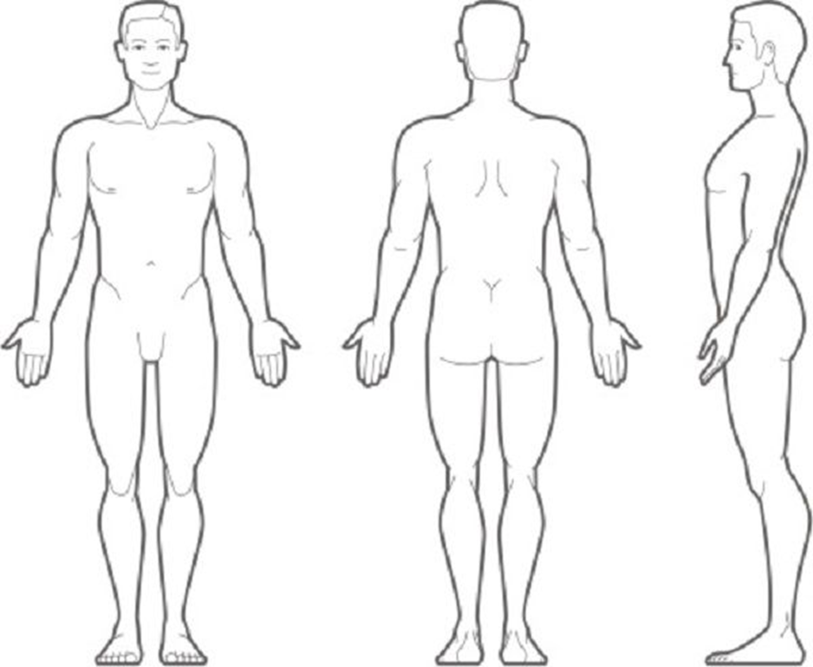

I have declared everything medically appropriate at the time of treatment and I have agreed to the treatment recommendation. I understand that the treatment may involve the removal of clothing and manual contact and I give my consent.

Signature: Date of first treatment:

Please give 48 hours’ notice when cancelling an appointment so that there is time to allocate to someone else. There is a charge of the full treatment costs for late cancellations and appointments not attended.

I declare that my medical status has not changed since my first treatment:

Date of subsequent treatments: Signature:

This information will not be shared with a second party and is used solely for Dragonflies Therapies Natural Health Studio.

